Hands-on 2: Functions, Structs, and Data Management

1. Prerequisites
- Terminal Access: Open your VS Code terminal.
- Working Directory: Ensure you are in your Go workspace (e.g., cd go-basics-module-2).
- Basic Knowledge: You should be comfortable with variables and basic types from Hands-on 1.

2. Why are we doing this?
Writing everything in a main function is like keeping all your tools in one giant pile. Functions allow us to reuse logic, Structs allow us to group related data (like a "Person" or "Product"), and Pointers allow us to share and modify that data efficiently without making unnecessary copies in memory.

3. Objective
- Create functions with multiple return values and named parameters.
- Use defer to manage resource cleanup.
- Define custom types using structs.
- Implement methods and understand the "Contract" of an interface.
- Mini-Project: Build an Employee Management System to store and update staff records.

4. Steps To Follow

Step 1: Mastering Functions
Create functions.go. We will explore how Go can return more than one value (a unique Go feature).
Simple Function Example
package main
import "fmt"
func greet() {
fmt.Println("Welcome to Go Language")
}
func main() {
greet()
}
Output:
Welcome to Go Language
Function with Parameters
Parameters are inputs passed to a function.
package main
import "fmt"
func add(a int, b int) {
fmt.Println(a + b)
}
func main() {
add(10, 20)
}
Output:
30

Function with Return Value
Functions can return values.
package main
import "fmt"
func add(a int, b int) int {
return a + b
}
func main() {
result := add(5, 3)
fmt.Println(result)
}
Output:
8
Multiple Return Values
Go supports returning multiple values.
package main
import "fmt"
func calculate(a int, b int) (int, int) {
return a + b, a * b
}
func main() {
sum, product := calculate(4, 5)
fmt.Println("Sum:", sum)
fmt.Println("Product:", product)
}

Output:
Sum: 9
Product: 20
Recursive Function
A function calling itself.
package main
import "fmt"
func factorial(n int) int {
if n == 1 {
return 1
}
return n * factorial(n-1)
}
func main() {
fmt.Println(factorial(5))
}
Output:
120

Anonymous Function
Function without a name.
package main
import "fmt"
func main() {
func() {
fmt.Println("Anonymous Function")
}()
}

Anonymous Function Assigned to Variable

You can also store anonymous functions in variables.

package main
import "fmt"
func main() {
greet := func() {
fmt.Println("Hello")
}
greet()
}

Output:
Hello

Variadic Function
Accepts multiple values.
package main
import "fmt"
func sum(numbers ...int) int {
total := 0
for _, value := range numbers {
total += value
}
return total
}
func main() {
fmt.Println(sum(1, 2, 3, 4))
}
Output:
10

package main
import "fmt"
// Function with multiple return values (result, success)
func divide(a, b float64) (float64, bool) {
if b == 0 {
return 0, false
}
return a / b, true
}
func main() {
// Using defer: This runs at the VERY end of the main function
defer fmt.Println("Calculation cycle complete.")
res, status := divide(10, 2)
if status {
fmt.Printf("Division Result: %.2f\n", res)
}
_, errStatus := divide(10, 0)
if !errStatus {
fmt.Println("Division failed: Cannot divide by zero.")
}
}

Run command:
go run functions.go
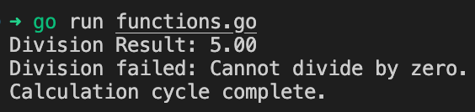
Key Concept: defer is often used to close files or database connections. It guarantees execution even if the function crashes.

Step 2: Structs and User-Defined Types
Create structs.go. Structs are the closest thing Go has to "Classes" in other languages.
package main
import "fmt"
// Define a custom structure
type Employee struct {
ID int
Name string
Position string
Salary float64
}
// A Method: This is a function attached to the Employee struct
func (e Employee) Display() {
fmt.Printf("ID: %d | Name: %s | Role: %s | Salary: $%.2f\n", e.ID, e.Name, e.Position, e.Salary)
}
func main() {
emp1 := Employee{
ID: 101,
Name: "Alice Gopher",
Position: "Senior Dev",
Salary: 95000,
}
emp1.Display()
}

Run command:
go run structs.go

Step 3: Pointers (Modifying Data)
Create pointers.go. By default, Go passes copies of data. To change the original data, we use pointers (*).
package main
import "fmt"
type Counter struct {
Value int
}
// This method uses a pointer receiver (*Counter) to modify the original value
func (c *Counter) Increment() {
c.Value++
}
func main() {
myCount := Counter{Value: 0}
myCount.Increment()
myCount.Increment()
fmt.Println("Final Count:", myCount.Value) // Should be 2
}

Run command:
go run pointers.go

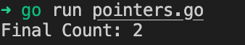

5. Mini-Project: Employee Information Manager
Create employee_mgr.go. This combines structs, methods, pointers, and user input to manage a "database" record.
package main
import (
"bufio"
"fmt"
"os"
"strings"
)
type Employee struct {
ID int
Name string
Active bool
}
func (e *Employee) ToggleStatus() {
e.Active = !e.Active
}
func main() {
// We use a Scanner to read full lines including spaces
reader := bufio.NewReader(os.Stdin)
fmt.Println("--- Create New Employee Record ---")
fmt.Print("Enter ID: ")
var id int
fmt.Scanln(&id) // Scanln helps clear the line after the number
fmt.Print("Enter Name: ")
// ReadString will capture "Demo User" entirely
name, _ := reader.ReadString('\n')
name = strings.TrimSpace(name) // Remove the newline character at the end
emp := Employee{ID: id, Name: name, Active: true}
fmt.Println("\nRecord Created Successfully!")
fmt.Printf("Current Info: %+v\n", emp)
fmt.Print("\nDeactivate this employee? (yes/no): ")
choice, _ := reader.ReadString('\n')
choice = strings.TrimSpace(choice)
if strings.ToLower(choice) == "yes" {
emp.ToggleStatus()
fmt.Println("Status updated to Inactive.")
}
fmt.Printf("\nFinal Record: ID:%d, Name:%s, IsActive:%t\n", emp.ID, emp.Name, emp.Active)
}

Run command:
go run employee_mgr.go

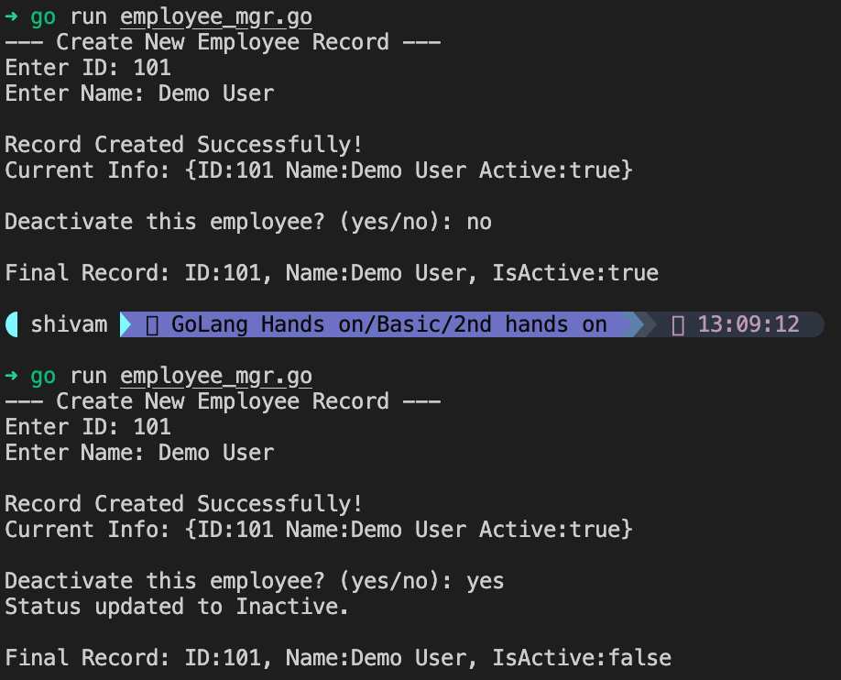

6. Checklist of Accomplishments
- [ ] Functions: Created functions with multiple return values.
- [ ] Defer: Successfully used defer for execution ordering.
- [ ] Structs: Defined and initialized a custom Employee structure.
- [ ] Methods: Attached functionality to a struct using receivers.
- [ ] Pointers: Used * to modify struct data within a method.
- [ ] Mini-Project: Build a program that creates and modifies a data record.

7. Conclusion
You've just leveled up from writing scripts to building systems. By using Structs, you can now model real-world data, and by using Methods and Pointers, you've learned how to make that data interactive and memory-efficient. This is the architecture used by major Go projects like Docker and Terraform!

Congrats!
You've successfully built a mini-data management system. You are now ready to handle complex data flows and project structures!

